

**UNIVERSITY OF BARISAL**

**PROJECT ON**

**Citizen’s Trust on Rural Government Delivery Service in Bangladesh: A Study on Arshinagar Union Parishad of Shariatpur District.**

**Submitted By**

**Sabuj Mia**

Roll No. :- 25

Batch No. :- 46

Course : **Computer Fundamentals and Office Application**

Department of Computer Science and Engineering ,

University of Barisal.

**EDGE: BU-CSE DIGITAL SKILLS TRAINING**

Contents

Abstract 3

Introduction 4

Background of the study 4

Statement of problem 6

Literature review 9

Significance 12

Project Objectives 12

Project Questions 13

Present Structural Arrangement of UP 13

Data Presentation, Analysis and Interpretation 16

Questionnaire: 17

Sample sizes: 17

Data Scaling and Analysis Method 17

Impact of demographic characteristics on trust 17

2.1 Age and trust: 17

2.2 Gender and Trust: 18

2.3 Education and Trust: 19

2.4 Income and Trust: 20

2.5 Occupation and Trust: 20

Table 5. Overall Trust on Union Parishad 20

Impact of Institutional Features on Trust 21

3.1 Competency and Trust: 21

3.2 Transparency and Trust: 22

3.3 Credibility of Commitment and Trust 24

3.4 Helpfulness and Trust: 24

3.5 Behavior and Trust: 25

Findings and Conclusion 26

Bibliography 28

Questionnaire: 30

# Abstract

This project endeavours to investigate citizen's level of trust on Union Parishad level in Bangladesh with particular aim to decide the organization components that influence their level of trust. The projector has moreover tried a few statistic factors to degree its impact on trust. This inquires about utilized mixed approach combination of qualitative and quantitative methods. A survey study has been conducted among the grown-up inhabitants of One Union Parishad in Bangladesh to assemble required information and data. Other than, the analyst managed a few key informant interviews. Both primary and secondary sources of information have also been utilized for encourage examination and deductions. A number of theories related to organization and statistic variables have been tried. The project aims to discover out the common level of citizen's believe on UP as an institution. Organization components like Competency, transparency, openness, fulfilment of promise and performance have been considered as explanatory factors to degree its impact on trust. In expansion to these, a few other chosen demographic highlights like Age, gender, and education have been examined to evaluate the generally organization believe on UP. Within the last investigation, the study has observed a low level of believe on UP. In general performance in transparency and service delivery in planning and decision making are basic variables of organization trust of UP. Among the statistic factors, gender and age have prevailing impact in believe building. Trust level is low at youthful and ancient age than the middle age. Interestingly the women have showed low level of trust on UP. But education is found to have no critical connection with trust building. Interests, the modern believe literature does not completely coordinate with the discoveries of the investigate.

# Introduction

This chapter introduces the common background of the project with specific research problem. It clarifies the importance and objective of the study. It also represents the research questions of this research. Moreover, this chapter reviews the important trust literatures based on the empirical study in different fields aiming to follow patterns in trust research both in worldwide and local context. It also reviews the literatures on Union Parishad (UP) to follow its present features in Bangladesh. This chapter identifies the scope as well as the limitation of the study. At last, it ends up with the structure of the study.

## Background of the study

“The topic of trust in government is a main area of concern across the world. Politicians and researcher community has shown their keen interest in this issue. The world is observing a declining trend in the levels of trust” ( Edelman Trust Barometer.2017). It is also true in almost all the advanced democratic countries. But not only the specific pattern but also the pace of the decrease varies from country to country (Blind 2007). It is an issue of discomfort among governments. Most of the government treated it as a potential threat which can create legitimacy crisis. Substantial amount of studies have been conducted on trust in government with a wide range of variations such as trust as a concept, its origin and also the consequences of declining trust. These explorations give a point of view to understand the phenomenon. It can be helpful to explore the dynamics of citizens’ trust in LGIs in Bangladesh.

Bangladesh's unitary government system is based on a constitutional provision establishing Local Government Institutions (LGIs) to provide for all the fundamental needs of the people in general.In Bangladesh, there are two kinds of LGIs: urban and rural. There are 64 Zila Parishad,495 Upazila Parishad,4,596 UPs serving as elected local government units in rural area, 12 City Corporations, and 330 Pourasavas (municipality) in urban regions in Bangladesh. In Bangladesh, UPs comprise the lowest level of rural local government administration. Bangladesh Constitution provide following article about local government:

1. Article 59. (1) “Local government in every administrative unit of the Republic shall be entrusted to bodies, composed of persons elected in accordance with law.”

Article 59. (2) Declares its functions as ‘administration and the work of public officers, the maintenance of public order, the preparation and implementation of plans relating to public services and economic development’

Article 60. “For the purpose of giving full effect to the provisions of article 59 Parliament shall, by law, confer powers on the local government bodies referred to in that article, including power to impose taxes for local purposes, to prepare their budgets and to maintain funds.”

The UPs have four major roles and responsibilities as per the UP Act, 2009: a) the maintenance of law and order and assistance to administration for this purpose, b) the adoption and implementation of development schemes in the fields of local economy and society, c) the performance of administrative and establishment functions, and d) the provision of public welfare services. In addition to these,there are 39 auxiliary functions. Its origins date back to the British era, although its name and parts of its functions have changed.UP has existed in Bangladeshi local governance for a long time.Union Panchayets were founded by the British government in the year 1870. After a number of modifications, it became UP in 1973.

Thus, it is evident that UP is a 145-year-old organisation. According to Bangladesh's constitution, the UP was established. According to the Constitution's Articles 59 and 60, the establishment, duties, and roles of these We have characterised LGIs.1.Numerous commissions and committees have been established over time, bringing in structural and functional sectors of UP and LGIs. However, no significant and visible changes have been noticed as yet. Its duties and responsibilities experienced a number of revisions, but it remained there throughout. As of right now, there is no substitute for this UP. Every union consists of multiple villages. There Bangladesh has 4,596 unions. The Local Government (UP) Act, 2009 states that a UP is composed of nine members, three of whom have been reserved as women, and a chairman. There is just one government-appointed permanent official in the UP, and both the government and the UP share pay costs (Aminuzzaman 2013). The lowest and oldest local government system is Union Parishad. It has been assisting the nation's rural development for more than a century. There are 4480 Union Parishads at preset, and the directly elected delegates govern the Union parishads. Its functions and Representatives follow various levels, regulations, and circulars from time to time.

## Statement of problem

There are so many research works on UP. In some of the previous research papers on UP, it has been studied that UPs have to struggle with several institutional challenges while working at the root level and also in delivering their services properly. UP members have shallow knowledge about their formal roles and responsibilities (Khan n.d.). Even sometimes a lack of commitment, a lack of vision as well as a lack of integrity and dishonesty of the leadership of UP are observed (Aminuzzaman 2011). The elected leaders of UP are not accountable in practice (Aminuzzaman 2014). Inadequate infrastructural capacity of UP and the financial insolvency of UP are obstacles for the effective performance of the UP (Khan n.d.). All the LGIs have their own sources of revenue from taxes, rates, fees and charges. But the UPs can generate only a small amount of revenue from their own sources in comparison to their needs for either their low revenue mobilization capacities or unwillingness to mobilize revenues (Bhattacharya et al 2013). The Chairman holds comparatively a powerful position and most of the time he takes decision consulting with a small circle of people, mostly the elite people (Aminuzzaman 2013). People have very low level of access in the project selection as well as in other decision making process of the UP in spite of the legal provisions of the UP Act to be transparent and participatory. People's participation and involvement of civil society were found inadequate in UP (Aminuzzaman 2013). Every decision is made without the knowledge of the mass people, especially, the marginal poor, women, and destitute (Aminuzzaman 2013).

Citizens’ level trust in government may be based on two important factors, one is the political activity and attitude of the government and the other one is on the service satisfaction. When the individual’s experiences are largely good, they tend to trust the state (Kumlin 2002, Rothstein and Steinmo 2002, cited in Christensen and Laegreid, 2003, p. 7). Now Citizens can be quite satisfied with specific public services and at the same time dissatisfied with government in general (Goodsell, 1994; Nye et al., 1997, p. 265). Politically the level of citizens’ trust in Bangladesh involves a paradoxical situation. Such as according to World Justice Project (WJP) rule of law index 2015, Bangladesh is placed is placed below of some of Africa’s conflicted countries and significantly lower than all the countries in South Asia (BIGD, 2014, p. 45). However on the other hand, according to a survey carried out by International Republican Institute (IRI) 73% of the population feels that Bangladesh is going in the right direction and is politically stable and 83% respondents are satisfied with the security situation . The paradoxical situation is because, if we consider rule of law (a situation where rules are implemented according to laws that are publicly promulgated and where enforcement is done equally) as an indicator of political stability and attitude of the government which is an important factor of finding out the level of trust of governemnt, two opposing results are being illustrated. Thus it is important to know to what extent the people are satisfied and their level of trust in the public service delivery at the local level which usually involves the individual experiences, rather finding out the trust in government. It has been studied that UP is not transparent and not accountable to the mass people. Even the female members of the UP face gender discrimination in the decision making process of the UP (Khan n.d.). The lack of community members’ awareness about the overall functions of UP such as sanitation, violence against women, family welfare etc. creates problem in the functioning of UP (Khan n.d.). On the other hand, the UNO, who works for formal coordination at upazila level have very little practical control over the activities taken by line departments (Aminuzzaman 2011). Evidence found that projects taken at upazila level are mostly centralized projects (Aminuzzaman 2011). UPs have limited control over the selection of those projects (Aminuzzaman 2011). UPs have some exceptions in projects like LGSP. There is no clear demarcation between jurisdiction of the MPs and the local government representatives (Khan n.d). The MPs (members of parliament) are expected to perform only advisory roles but the invisible and unofficial influence or interventions by the local MPs on UPs have been criticized as another major challenge though as per the act, UP members are not at all accountable to MP (Aminuzzaman 2011). Again the different tiers like UP, Upazila Parishad, Pourashava are constituted under separate laws have somefunctional overlapping. There was hardly any chance for the community members to lodge any complaint to the designated authority in case of any service delivery forgery or corruption of the UPs (Mohammed 2010 cited in Aminuzzaman 2013). In Bangladesh, the only elected local institution is this UP which still remains weak due to the dark shadow of inefficiency, scarcity of resources and political turmoil (Haque 2009). The red tapes, administrative complexities of UP also hampers the activities of the UP (Khan n.d.).

Given that the majority of Bangladeshis reside in the country's Rural areas and that the country is experiencing a difficult globalisation period with rapid rural area growth, there is an urgent need for improved local service delivery. People's needs are always growing, yet local government institutions like the municipality are not providing the services that the public expects, and as a result, the public is denied timely access to services.Additionally, the populace is ignorant of the services they are expected to use.

The administrative apparatus's numerous bureaucratic measures and the services' ambiguous policies have eroded public confidence in local service delivery. Ensuring that the public has faith in local government entities like municipalities is the duty of both the federal government and the elected officials serving in such capacities.

In conclusion, the issues raised by the earlier research are a lack of transparency, a low degree of institutional visibility, a poor participatory approach, and a dubious perception of the institution. Additionally, existing literature has mostly focused on citizen satisfaction with urban infrastructure in city corporations of large cities, leaving a gap in the literature regarding citizen satisfaction with rural government delivery services in grassroots rural areas. Therefore, this study aims to address this gap in the literature by assessing the satisfaction of rural government delivery services in the Arshinagar Union Parishad under the Shariatpur district of Bangladesh. Thus, there's a slim chance that this could be evidence of Bangladesh's low level of public trust in the UPs as a grassroots organization in the Rural government system that can be helped to achieve SMART governance under vision 2041.

## Literature review

The effect of the Local Government Act of 2009 in Bangladesh on the operations of Upzila Parishads (UP), or local administrations, with a focus on public engagement and accountability. All through the chapters, the authors examine the relationship between social accountability and the current legal framework of the UZP, assess the degree of political conviction and spontaneous social participation, cast doubt on the effectiveness of the Citizen's Charter and the Right to Information as social accountability mechanisms, and offer solutions to some of the issues affecting people's accountability and participation in the UZP (Chowdhury, S. & Panday, P.K.2018).

The degree of trust as seen from both a horizontal and vertical angle. The study looked at the connections between socioeconomic and interpersonal variables and trust. There is no evidence linking gender to organisational trust. In Bangladesh, the ancient. Older workers are viewed as more reliable than middle-aged workers in the company. Tribal workers receive a high degree of trust from superiors as well as from their peers. Lower educated workers have a higher level of trust in their colleagues. The results of this study also demonstrate that employees have greater faith in their peers than in their bosses (Anisuzzaman .2012). the difficulties in getting people to participate in UP in Bangladesh. His investigation found that political corruption, a lack of resources, a lack of sincerity among chairmen, and incompetence plague local administration. etc. Additionally, he noted that although the various UP SCs serve as the primary institutional channel for public participation in local decision-making, the level of public participation is determined to be low(Haque. 2009).Aminuzzaman (2011, 2014) highlighted the institutional characteristics and issues that the UPs in Bangladesh are currently facing.

He maintained that when providing services at the union level, the UPs are up against various obstacles. The community members' inadequate comprehension of functions, Major challenges for the UPs are identified as low member awareness, the chairman's dominance in decision-making, the exclusion of women members, low participation, centralised project design and implementation, a strained relationship between elected representatives and local officials, etc. The patient’s trust on Upazila Health Complex (UHC) which provided primary health care at upazila level in Bangladesh. The research identified major trust arenas as well as potential factors of trust variation. The study showed patients were enjoying high level of trust on UHC. Most of the patients treated doctors as committed, competent, moderately cooperative providing compassionate services. Overall their trust level is high. In case of analyzing the trust variables, age has inverse relation with trust. Older patients have less trust than the younger ones. Gender and monthly household expenditure have no significant relation with trust. The most surprising is that doctor’s commitment has no correlation with trust. However doctor’s competence and level of satisfaction is highly significant. Even the quality of nursing service and integrity are found influential. The study came up with the observation that doctor’s competence, level of satisfaction, quality of nursing service and integrity are important in explaining trust(Hossain. 2015). Aminuzzaman, S.M. (2011) emphasised the institutional characteristics and difficulties that the UPs in Bangladesh face nowadays.

In short, research shows that the dimension of trust varies across countries, contexts, cultures and organizations. Trust factors that are very important in one context may not affect other contexts. From the perspective of Bangladesh, there seems to be a paradoxical relationship between total institutional trust and trust factors. Although Bangladeshis trust civil servants or politicians less than individuals, they strongly trust institutions such as the central government, the higher judiciary, the army and the deputy commissioner's office. The literature review on trust and UP shows that despite local governments, the roles and functions of local governments in Bangladesh, Citizens trust on Urban area, there is no research on trust focused on Rural governments delivery system like Union Parishad at grassroots-level in rural area in Bangladesh as such. This study will help see the overall confidence and effectiveness of Union Parishad activities towards development. Therefore, this research is reliable both for government and bureaucrats, academics, civil society for further research or other movements.

## Significance

Literature appears that numerous investigate works have been conducted with respect to the regulation challenges, budgetary administration, budgeting and other issues of the UPs in Bangladesh. Indeed there have been so numerous investigates on believe issues. But the past works have barely touched the issue of citizen’s believe on UP. This think about has attempted to investigate whether there is any believe crevice among the citizens.

When believe collapses in a society, the agreement of the entirety society endures (Bok 1979 cited in Haque 2015). Kim (2005) accepts, higher citizens’ believe in open educate guarantees great administration as believe is an fixing of great administration (cited in Haque 2015). As UP is the as it were chosen body working for the rustic individuals, it needs to be an viable one. To guarantee great administration at UP, believe require to be guaranteed as well. So evaluating believe level is very important. If there is doubt on UP, individuals may remain absent from UP and it may ended up broken, ineffectual and lethargic. This believe issue may have an suggestion on the benefit conveyance and benefit quality of UP.

UP is a government formative body which works for advancement at the grass root level. Vision 2041, 8th Five year arrange implement this institution to be a driving institution at union level. In this manner, it needs to be more viable, more utilitarian, more dynamic, more reliable and more solid. This consider has altogether watched the community’s level of believe on UP as well as the components influencing citizen’s believe. The discoveries of the consider is likely to include esteem to arrangement making to improve believe on UP.

## Project Objectives

The main objectives of the project paper are:

* To find out the level of citizens’ trust in the service delivery of rural government based on the provisions of the citizen charter.
* To explore the behaviour that impedes and expedites the level of citizens trust in the in the service delivery of Union Parishad in rural government.

## Project Questions

This project involves certain research questions based on the objectives of the research, which are;

1. What is the level of citizen’s trust on Union Parishad as an institution?

2. What factors play the major role in impedes the level of citizens’ trust on the service delivery of the Union Parishad?

3. What factors play the major role in expedites the level of citizens trust on service delivery of Union Parishad?

# Present Structural Arrangement of UP

There are two types of LGI services in Bangladesh: rural and urban. The UP was established in 1870 as the lowest level of local government in rural areas (Aminuzzaman 2013). It continued to exist (under different names) for 145 years. On average, each upazila in Bangladesh has about 12 UPs. The following diagram briefly shows the general organizational chart of local government.

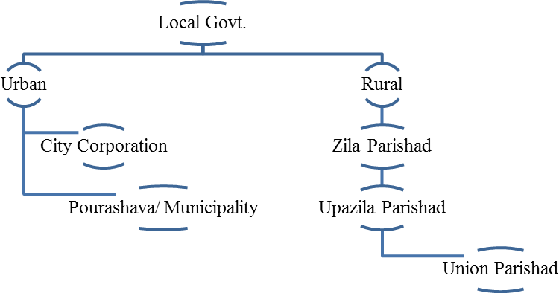

Figure 1: Organogram of Local Government

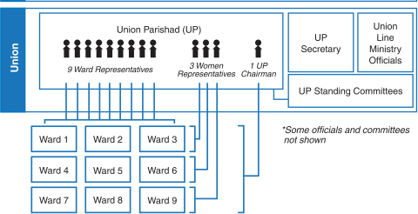

Figure 2: Organogram of UP

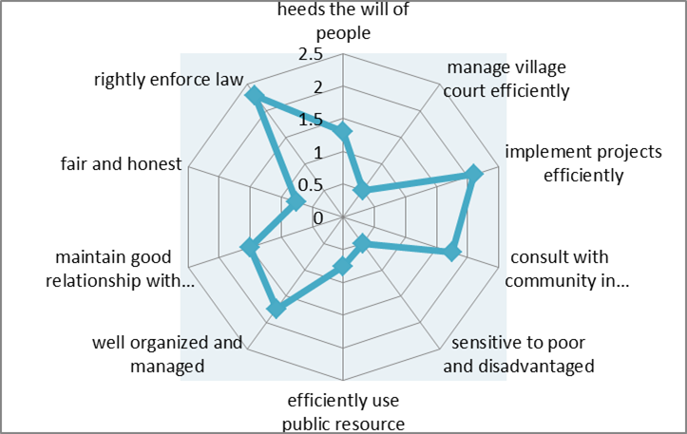

Figure 3: Institutional Features of UP in Bangladesh

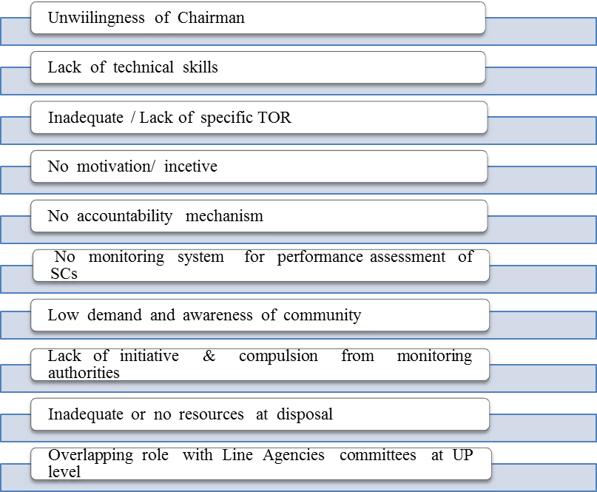h

Figure 4: Impeding Factors Affecting Performance of SCs of UP

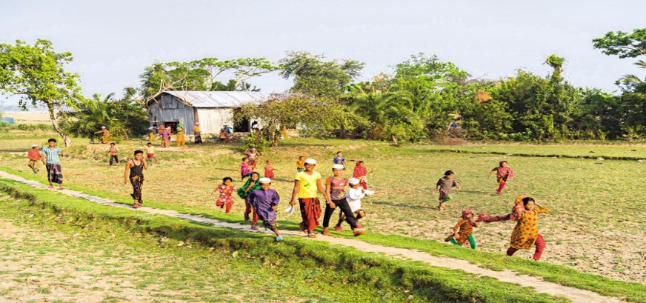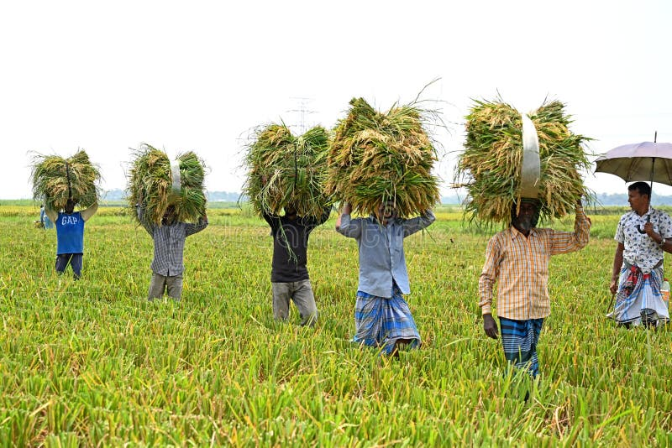

Image: Rural Area in Bangladesh

# 

# Data Presentation, Analysis and Interpretation

This chapter outlines the research areas, the demographic profile of the respondents and the scaling method of the study. The purpose of this chapter is to present the empirical data and field-specific conclusions of the study. It aims to analyse empirical findings based on an analytical framework. The following research questions were asked in this study: 1) what is the trust of citizens in UP as an institution? 2. What factors play the major role in impedes the level of citizens’ trust on the service delivery of the Union Parishad ? 3. What factors play the major role in expedites the level of citizens trust on service delivery of Union Parishad?

## Questionnaire:

In addition to the in-depth study of secondary data and theoretical discourse analysis, the research is strongly based on interviewing respondents. There were 16 closed questions in the questionnaire. The questionnaire was divided into three parts. The first part concerned the profile of the respondents. In the second part citizens were asked how much they trust UP. In the third part they were asked to measure their opinions on the institutional factors proposed in the analytical framework.

Sample sizes: The sample populations were purposively selected from one Union of the nine selected UP wards. The total sample size was 70. About 8-10 respondents were interviewed from each ward, 2/3 of which were women from ward responsible for women. The samples were taken mainly from the heads of households covering all departments of UP.

## Data Scaling and Analysis Method

The data collected through in depth interview was analysed using SPSS. The data are obtained on a nominal and ordinal scale. Numbers assigned to nominal scale variables have no mathematical value. On the other hand, an ordinal scale indicates an order. Initially, the level of trust was measured on a likert scale with a scale of 1-5, and during data processing, the scale was grouped as 1-2 as low, 3 as medium, 4-5 as high. The collected data has been presented and analyzed below:

## 

## Impact of demographic characteristics on trust

2.1 Age and trust: Age is considered as one of the important variables according to which the level of trust is likely to vary.

Table 1. Overall Trust on Union Parishad

|  |  |  |  |  |
| --- | --- | --- | --- | --- |
|  | | No. of Respondent | Trust Level (%) | |
| High | Low |
| Age | Young Age (17-35) | 23 | 30.44 | 69.56 |
| Middle Age (36-55) | 30 | 33.34 | 66.66 |
| Senior Age (56+) | 17 | 29 | 71 |
|  | Total Percentage | 70 | 31.43 | 68.57 |

Source:Field Survey, Arshinagor Union parishad, (September-December, 2024)

2.2 Gender and Trust:The study focuses on gender, one of the demographic characteristics that is likely to have some impact on general trust levels of citizens. Table 2. Overall Trust on Union Parishad

|  |  |  |  |  |
| --- | --- | --- | --- | --- |
|  | | No. of Respondent | Trust Level (%) | |
| High | Low |
| Gender | Male | 41 | 39.93 | 62.07 |
| Female | 29 | 65.85 | 34.15 |
|  | Total Percentage | 70 | 36.0 | 64.0 |

Source: Field Survey, Arshinagor Union parishad,( September-December, 2024).

2.3 Education and Trust:The level of trust can be influenced by the level of education of the respondents.

Table 3. Overall Trust on Union Parishad

|  |  |  |  |  |
| --- | --- | --- | --- | --- |
|  | | No. of Respondent | Trust Level (%) | |
| High | Low |
| Educational Qualification | Illiterate | 19 | 36.84 | 63.16 |
| Literate to Primary Education | 20 | 30 | 70 |
| Secondary to Higher Secondary | 19 | 26.31 | 73.69 |
| Graduate and Higher Degree | 12 | 25 | 75 |
|  | Total Percentage | 70 | 30 | 70 |

Source: Field Survey, Arshinagor Union parishad, (September-December, 2024)

2.4 Income and Trust:The level of trust can be influenced by the income level of the respondents.

Table 4. Overall Trust on Union Parishad

|  |  |  |  |  |
| --- | --- | --- | --- | --- |
|  | | No. of Respondent | Trust Level (%) | |
| High | Low |
|  | 0-5000 | 24 | 33.33 | 66.67 |
|  | 5000-10000 | 23 | 30.43 | 69.57 |
| Income | 10000-30000 | 11 | 36.36 | 63.64 |
|  | 30000+ | 12 | 41.66 | 58.37 |
|  | Total Percentage | 70 | 34.28 | 65.72 |

Source: Field Survey, Arshinagor Union parishad, (September-December, 2024)

### **2.5 Occupation and Trust:**

The level of trust can be influenced by the professional status of the respondents.

# Table 5. Overall Trust on Union Parishad

|  |  |  |  |  |
| --- | --- | --- | --- | --- |
|  | | No. of Respondent | Trust Level (%) | |
| High | Low |
| Occupational Status | Working People | 41 | 29.26 | 70.74 |
|
| Non-working People | 34 | 31.03 | 68.97 |
| Total Percentage | 70 | 30 | 70 |

Source: Field Survey, Arshinagor Union parishad, (September-December, 2024)

## Impact of Institutional Features on Trust

### 3.1 Competency and Trust:

|  |  |  |  |
| --- | --- | --- | --- |
| Table 6: **Effective Role of Union Parisad in Local Development** | | | |
| Response Category | No. of Service Receiver | Percent | Cumulative Percent |
| Yes | 18 | 30 | 30..0 |
| No | 42 | 70 | 100 |
| Total | 60 | 100 |  |

Source: Field Survey, Arshinagor Union parishad, (September-December, 2024)

Table 9. Officials Knowledge on their Responsibility

|  |  |  |  |
| --- | --- | --- | --- |
| Response Category | No. of Service Receiver | Percent | Cumulative Percent |
| Strongly Agree | 6 | 10 | 10 |
| Agree | 3 | 5 | 15 |
| Neutral | 7 | 11.7 | 26.7 |
| Disagree | 24 | 40 | 66.7 |
| Strongly Disagree | 20 | 33.3 | 100 |
| Total | 60 | 100 |  |

Source: Field Survey, Arshinagor Union parishad, (September-December, 2024)

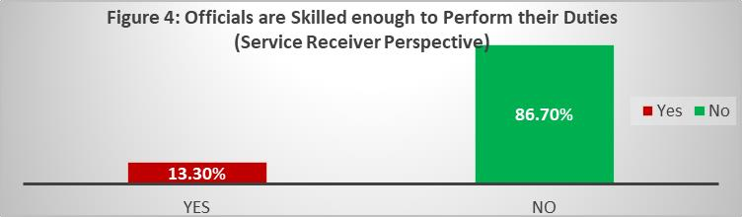

Source: Field Survey, Arshinagor Union parishad, (Sepember-December, 2024)

### 

### 3.2 Transparency and Trust:

Table 10. Mechanisms for Ensuring Accountability and Transparency

|  |  |
| --- | --- |
| Response Category | No. of Respondents |
| Billboards | 45 |
| Ward Committee Meetings | 22 |
| Direct Information Access | 14 |
| Notice Board | 33 |
| Audit | 8 |

Source: Field Survey, Arshinagor Union parishad, (February-May, 2024)

Table 11. Peoples Access in Budget Making Procedure

|  |  |  |  |
| --- | --- | --- | --- |
| Response Category | No. of Officials | Percent | Cumulative Percent |
| Strongly Agree | 5 | 50 | 50 |
| Agree | 3 | 30 | 80 |
| Neutral | 2 | 20 | 100 |
| Total | 10 | 100 |  |
|  |  |  |  |

Source: Field Survey, Arshinagor Union parishad, (September-December, 2024)

### 3.3 Credibility of Commitment and Trust

Table 12. Fulfilling Election Mandate by Union Parisad Representatives

|  |  |  |  |
| --- | --- | --- | --- |
| Response Category | No. of Service Receiver | Percent | Cumulative Percent |
| Yes | 16 | 26.7 | 26.7 |
| No | 44 | 73.3 | 100 |
| Total | 60 | 100 |  |

Source: Field Survey, Arshinagor Union parishad, (September-December, 2024)

The picture showed that the election mandate was fulfilled by the Union representatives. Most of the officers (80%) agreed with the statement and the rest (20%) disagreed.

### 3.4 Helpfulness and Trust:

Table 14. Helpful Minded Officials

|  |  |  |  |
| --- | --- | --- | --- |
| Response Category | No. of Service Receiver | Percent | Cumulative Percent |
| Strongly Agree | 9 | 15 | 15 |
| Agree | 7 | 11.66 | 26.66 |
| Neutral | 8 | 13.33 | 39.99 |
| Disagree | 19 | 31.7 | 71.69 |
| Strongly Disagree | 17 | 28.31 | 100 |
| Total | 60 | 100 |  |

Source: Field Survey, Arshinagor Union parishad, (September-December, 2024)

### 3.5 Behavior and Trust:

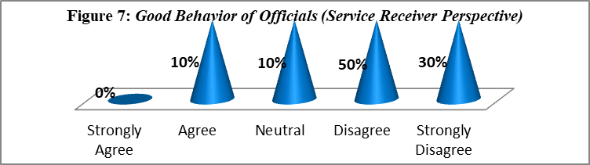

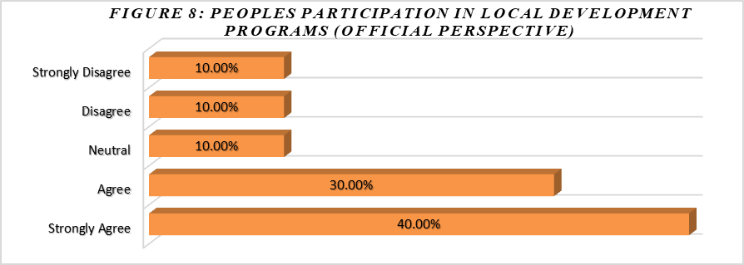

Source: Field Survey, Arshinagor Union parishad, (September-December, 2024)

# Findings and Conclusion

The following findings are summarized based on primary data analysis and literature review. Receiving services from the Union Parishad is a fundamental right of all citizens. The Union Parishad is considered a necessary condition for rural development. Therefore, Bangladesh government established Union Parishad division so that the farmers can easily improve their situation. The purpose of this study was to find out the current situation of union parishad conditions in terms of service delivery and its effectiveness. This study is based on one Union Parishad under Shariatpur District. Citizens' trust in Union Parishad is low. Citizens generally have a negative perception of Union Parishad officials. Citizens have some negative experiences with LGI operators. People's perception that Union municipalities are not efficient in service delivery. 86.7% of the service recipients agreed that top officials are not skilled enough to perform their duties properly. Most of the time they were not professional and their behavior was not good. 73.3% of the respondents did not agree that civil servants' knowledge of their duties is minimal. They were in a hurry to achieve their interests.

The manner, processes and practices related to reporting, transparency and citizen participation the mechanism can greatly increase the confidence of citizens. The participation of citizens in local government activities is an effective role in terms of local development. Community participation supports better public service delivery and management at the local level. However, most of the respondents (53.3%) thought that people did not participate in local development programs. They said that the mass people have minimal access to local development programs and policies. The Union Parishad did not fulfil its wish.

Most of the respondents (73.3%) thought that the Union Parishad representatives did not fulfil the electoral mandate. Mostly they were busy with their own interests. They engaged in corruption, nepotism, etc. Most of the service recipients do not trust the elected and unelected officials of the Union Parishad.

The study shows that the services provided by the Union Parishad department are not sufficient to ensure efficiency and trust of the citizens. The overall performance of the Union Parishad division is not at a satisfactory level. Citizens have negative experiences with Union officials. Union Parishads are halfway between central government and local government and there is a very important level of administrative and political connectivity. More importantly, the Union acts as a bridge between local and national administrations to implement government programs. Union administration has recently been subjected to democratic control by directly elected representatives. Elected representatives and bureaucrats are an integral part of the administrative and political process of Union administration. But most often elected and unelected officials are unprofessional in what they do. They are not providing the best service to people. Even the elected representatives do not meet the demands of the public. They do not focus on people's interests. They are busy with their own interests. These are the reasons why citizens do not trust the union officials. Civil servants must pay attention to ensure effective service delivery. Effective service delivery by the Union Parishad depends on communication between the actors, elected politicians and bureaucrats. There are three main administrative players directly and indirectly associated with the Union Parishad. The roles and functions of these actors in the Union Parishad is a hot topic of debate. A clear understanding of the duities and responsibilities of the main actors can be considered as the first important step towards the proper functioning of the Union Parishad.

# Bibliography

Adhikary, A. (2010). *Union Parishad and Poverty Reduction strategies at the local level: A study of Government Failure,Master,BRAC University.*

Aminuzzaman, S. M. (2010). *Local Government and Development in Bangladesh: Lessons Learned and Challenges for Improving Service Delivery of Union Parishad (UP), Dhaka: Ministry of LGRD & Cooperatives, United Nations Development Program (UNDP).*

Aminuzzaman, S. M. (2011). *Local Governance Innovations: An Assessment of the Challenges for Mainstreaming Local Governance Support Program, in Jamil et al. ed. Understanding Governance and Public Policy in Bangladesh, Dhaka: North South University. Ch. 10. PP 195- 214.*

Aminuzzaman, S. M. (2012). *Trust Within Field Bureaucracy: A Study on District Administration in Bangladesh. Master. North South University.*

Aminuzzaman, S. M. (2013). *Governance at Grassroots–Rhetoric and Reality: A Study of the Union Parishad in Bangladesh, in Jamil et al. ed. In Search of Better Governance in South Asia and Beyond, Switzerland: Springer. PP 201-222.*

Aminuzzaman, S. M. (2014). *Democratic Local Governance Capacity and Natural Disasters- Building Community Resilience: Bangladesh Case Study, Center for Cultural and Technical Interchange, East West Center, Hawaii, USA.*

Aminuzzaman, S. M. (2016). *Paper ‘Institutional Trust and its implications on Disaster Management of the Rural Local Government (UP) in Bangladesh’ presented to The Future of Local Governance in a “New” Development Agenda. Cutting Edge Research, Reality Changing Policies, Stockholm.*

Aminuzzaman, S. M. (2016). *Political Economy of Local Governance: A Study of the Grassroots level Local Government in Bangladesh, [Online]. Available at: http://paperroom.ipsa.org/papers/paper_30718.pdf .*

Amnizzuman, S. M. (2016). *Research on Standing Committees of Union Parishad, Dhaka: UNDP.*

Askvik, S. (2011). *The Significance of Institutional Trust for Governance in Bangladesh, in Jamil et al. ed. Understanding Governance and Public Policy in Bangladesh, Dhaka: North South University. Ch. 5. PP 91-110.*

bdnews24.com. (2016). *Bangladesh’s literacy rate rises to 70 percent, education minister says. [Online]. Available at http://bdnews24.com/bangladesh/2015/06/16/bangladeshs- literacy-rate-rises-to-70-percent-education-minister-says.*

Bhattacharya, D. a. (2013). *Finance for Local Government in Bangladesh: An Elusive Agenda, Dhaka: Center for Policy Dialogue & Chr. Michelsen Institute.*

Butler, J. K. (1991). *Towards Understanding and measuring conditions of trust: Evolution of a Conditions of Trust Inventory. Journal of Management. 17.*

Ferdaush, J. a. (2011). *Gender Inequality in Bangladesh. Dhaka : Unnayan Onneshan -The Innovators, Dhaka, 2011.*

Fukuyama, F. (1995). *Trust: The Social Virtues and The Creation of Prosperity. London: Hamish Hamilton.*

# Questionnaire:

**Trust Survey on UP in Bangladesh**

*[The purpose of this research is to measure citizen’s trust on UP in Bangladesh. This research is going to be conducted for partial fulfilment of Honours in Public Administration from Barishal University; Barishal The data collected through this study will be only used for research purpose. The identity of the respondents will never be disclosed.]*

**Part A. Profile of the Respondents**

*(Please put tick mark in the appropriate number.)*

1. Gender: 1. Male 2. Female
2. Age (Current): …………….
3. Educational Qualification:
   1. Illiterate
   2. Can sign name only
   3. Primary level
   4. Secondary level
   5. Higher Secondary level
   6. Graduate
   7. Post Graduate
4. Current residence (Ward No): .....
5. Income level:

1. (0 -5000)

2. (5000-10000)

3. (10000-30000)

4. (30000+)

**Part B. Citizen’s Trust on UP**

*(Please put tick mark in the appropriate number.)*

1. To what extent, you have trust in the way UP elected Officials manage UP affairs?

|  |  |  |  |  |  |
| --- | --- | --- | --- | --- | --- |
| Lowest level  of trust | Quite Low  level of trust | Average  level of trust | Quite High  level of trust | High level of  trust | Don’t know |
| 1 | 2 | 3 | 4 | 5 | 9 |

1. How much you have trust on Behaviour of officials ?

|  |  |  |  |  |  |
| --- | --- | --- | --- | --- | --- |
| Lowest level  of trust | Quite Low  level of trust | Average  level of trust | Quite High  level of trust | High level of  trust | Don’t know |
| 1 | 2 | 3 | 4 | 5 | 9 |

1. In your assessment, how much you have trust on UP as an Institution.

|  |  |  |  |  |  |
| --- | --- | --- | --- | --- | --- |
| Lowest level  of trust | Quite Low  level of trust | Average  level of trust | Quite High  level of trust | High level of  trust | Don’t know |
| 1 | 2 | 3 | 4 | 5 | 9 |

**Part C. Citizen’s Perception about Institutional Factors of UP**

*(Please put tick mark in the appropriate number.)*

1. To what extent do you believe that effective role of UP in local development ?

|  |  |  |  |  |  |
| --- | --- | --- | --- | --- | --- |
| Strongly  Disagree | Disagree | Slightly Agree | Agree | Strongly Agree | Don’t know |
| 1 | 2 | 3 | 4 | 5 | 9 |

1. In your opinion, how do you rate that budget allocation declared in open meeting is truly implemented?

|  |  |  |  |  |  |
| --- | --- | --- | --- | --- | --- |
| Strongly  Disagree | Disagree | Slightly Agree | Agree | Strongly Agree | Don’t know |
| 1 | 2 | 3 | 4 | 5 | 9 |

1. To what extent do you agree trust on Transparency of UP ?

|  |  |  |  |  |  |
| --- | --- | --- | --- | --- | --- |
| Strongly  Disagree | Disagree | Slightly Agree | Agree | Strongly Agree | Don’t know |
| 1 | 2 | 3 | 4 | 5 | 9 |

1. 10. In your opinion, how do you rate that helpful minded officials of UP?

|  |  |  |  |  |  |
| --- | --- | --- | --- | --- | --- |
| Strongly  Disagree | Disagree | Slightly Agree | Agree | Strongly Agree | Don’t know |
| 1 | 2 | 3 | 4 | 5 | 9 |

1. In your observation, how much you trust that UP elected officials have knowledge on their responsibility?

|  |  |  |  |  |  |
| --- | --- | --- | --- | --- | --- |
| Strongly  Disagree | Disagree | Slightly Agree | Agree | Strongly Agree | Don’t know |
| 1 | 2 | 3 | 4 | 5 | 9 |

1. How do you rate that you have trust on UP elected officials about the fulfilment of their commitment?

|  |  |  |  |  |  |
| --- | --- | --- | --- | --- | --- |
| Strongly  Disagree | Disagree | Slightly Agree | Agree | Strongly Agree | Don’t know |
| 1 | 2 | 3 | 4 | 5 | 9 |

1. Can you meet UP officials during your functional necessity?

|  |  |  |  |  |  |
| --- | --- | --- | --- | --- | --- |
| Strongly  Disagree | Disagree | Slightly Agree | Agree | Strongly Agree | Don’t know |
| 1 | 2 | 3 | 4 | 5 | 9 |

1. In your opinion, how will you rank overall performance of UP?

|  |  |  |  |  |  |
| --- | --- | --- | --- | --- | --- |
| Highly  dissatisfied | Dissatisfied | Slightly  Satisfied | Satisfied | Very satisfied | Don’t know |
| 1 | 2 | 3 | 4 | 5 | 9 |